February 15, 2024

Dear Families and Community Members:

We are pleased to present you with the Annual Education Report (AER), which provides key information on the 2022-23 educational progress for Holland Language Academy. The AER addresses the complex reporting information required by federal and state laws. The school’s report contains information about student assessment, accountability, and teacher quality. If you have any questions about the AER, please contact Iliana Vazquez for assistance.

The AER is available for you to review electronically by visiting the following website https://www.mischooldata.org/, or you may review a copy in the main office at your child’s school.

For the 2023-24 school year, schools were identified based on previous years’ performance using definitions and labels as required in the Every Student Succeeds Act (ESSA). A Targeted Support and Improvement (TSI) school is one that had at least one underperforming student subgroup in 2022-23. An Additional Targeted Support (ATS) school is one that had a student subgroup performing at the same level as the lowest 5% of all schools in the state in 2021-22. A Comprehensive Support and Improvement (CSI) school is one whose performance was in the lowest 5% of all schools in the state or had a graduation rate at or below 67% in 2021-22. Some schools are not identified with any of these labels. In these cases, no label is given.

Our school was identified as a School that has not been given a label.

Based on comparative M-STEP data from 2021-2022 and 2022-2023, there was an overall decrease in performance in ELA and increased performance in Mathematics for participating students in grades third through fifth. A factor playing into these results has been due to retention of staff. Although there was an increase in our overall math performance, the decrease in our overall performance of students achieving proficiently in ELA demonstrates the greatest need continues to be in reading.

For this reason,we utilize Tier II providers and Instructional assistants to primarily focus on supporting math and reading instruction. Based on achievement data, our focus will remain in increasing student outcomes in these areas.

- School Assignment/Transfer
  - Fundamentally, student assignment to a school shall be determined by attendance areas. Such areas will be adjusted to balance class size, to maintain racial and socioeconomic balance, and to maintain teacher-student ratios.
  - When feasible, children in the same family will be assigned to the same school, but children may be assigned to different schools when they live in a divided area, an overloaded area, or when requested by a parent and they can provide their own transportation.
  - Whenever possible, commitments made, in writing, to parents in earlier years - either implicitly by tradition or verbally - will be given priority in the process of assigning students for the year ahead. Placement policies and individual placements will be reviewed annually and adjusted when necessary.
  - When parents request that their child attend a school other than the one in their attendance area, they will be asked to sign the Student Transfer Agreement.
  - When families relocate from one neighborhood to another within the District during the school year, the children affected may continue their education at their original school if parents provide transportation to/from school.
- Class and Grade Assignment/Transfer
  - Assignments to class and grade shall be made by the principal after consultation with relevant staff.
  - Placement will be based on several factors including the intellectual, physical, social, and emotional development of the student as revealed by the use of available data and observations of the staff.
  - Each principal shall establish the criteria, including the intellectual, social, and emotional characteristics, by which students are assigned to classes and/or teachers or are transferred after initial assignment.
- The following procedures shall be followed in a transfer of a student within a school:
  - A written request shall be made to the principal by the parent of the student, a professional staff member, or by a student. Transfer requests may also be initiated by the principal.
  - After consultation with the appropriate personnel, a determination regarding the validity of the request shall be made by the principal.

If the transfer request is initiated by the District or a minor student, parents shall be advised of the request and the reasons it will be beneficial to the student or is necessary to maintain program effectiveness. They shall be advised of their rights of appeal if they do not agree with the transfer.
- THE STATUS OF THE 3-5 YEAR SCHOOL IMPROVEMENT PLAN
HLA continues to implement the School Improvement Plan created for the 2023-2024 school year, with modifications made for the 2022-2023 school year. We will be working on updating our plan to reflect current needs for the upcoming 2024-2025 school year.

- A BRIEF DESCRIPTION OF EACH SPECIALIZED SCHOOL
1. Severe Multiple Impairments Classrooms

Two Special Education Programs designed to serve elementary age students with Severe Multiple Disabilities. These classrooms operate according to the regulations defined by the Individuals with Disabilities Education Act (IDEA) and the Michigan Administrative Rules for Special Education (R 340.1748).

2. Early Childhood Special Education Classrooms

Three Special Education Programs designed to serve Preschool age students (3 through 5 years) with Disabilities. These classrooms operate according to the regulations defined by the Individuals with Disabilities Education Act (IDEA) and the Michigan Administrative Rules for Special Education (R 340.1755).

3. Classrooms for students with Hearing Impairments

Three Special Education Programs designed to serve preschool through 12th grade students with Hearing Impairments. These classrooms operate according to the regulations defined by the Individuals with Disabilities Education Act (IDEA) and the Michigan Administrative Rules for Special Education (R 340.1742).

4. Autism Spectrum Disorder Classrooms

Three Special Education Programs designed to serve preschool through 12th grade students with ASD. These classrooms operate according to the regulations defined by the Individuals with Disabilities Education Act (IDEA) and the Michigan Administrative Rules for Special Education (R 340.1758).
- IDENTIFY HOW TO ACCESS A COPY OF THE CORE CURRICULUM, A DESCRIPTION OF ITS IMPLEMENTATION, AND AN EXPLANATION OF THE VARIANCES FROM THE STATE’S MODEL
The framework for developing curriculum is established through the Michigan Department of Education (MDE). Within that framework, local schools adopt the core curriculum as designed, or modify the curriculum to address local needs. Currently, our district has written curriculum maps Pre-K-12 for Math and ELA that are aligned to the Michigan Academic Standards. The Grade Level Content Expectations (GLCE’s) in the area of Social Studies will continue to be used through 2020.

Our curriculum is aligned with the State of Michigan content standards, which are contained in the Michigan Academic Standards Page, on the State of Michigan website: http://www.michigan.gov/mde/0,4615,7-140-28753_64839_65510---,00.html.
Pacing guides and curriculum guides are available on the district website or through the Office of School Improvement. Holland Public Schools has a defined guaranteed and viable curriculum for all students and core instruction time is held at a high standard.
- THE AGGREGATE STUDENT ACHIEVEMENT RESULTS FOR ANY LOCAL COMPETENCY TESTS OR NATIONALLY NORMED ACHIEVEMENT TESTS

ELA
2021-2022
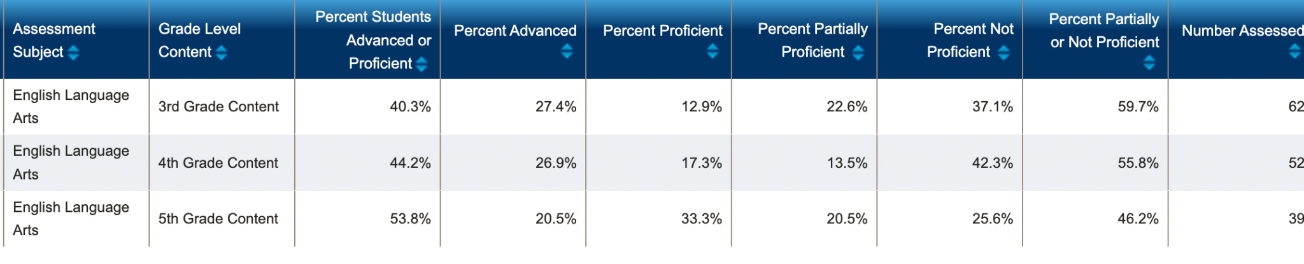
2022-2023
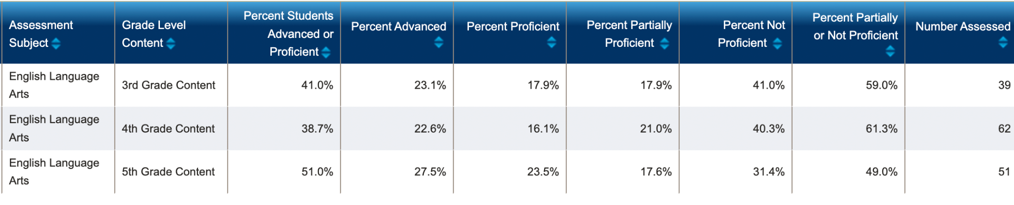

MATH
2022-23
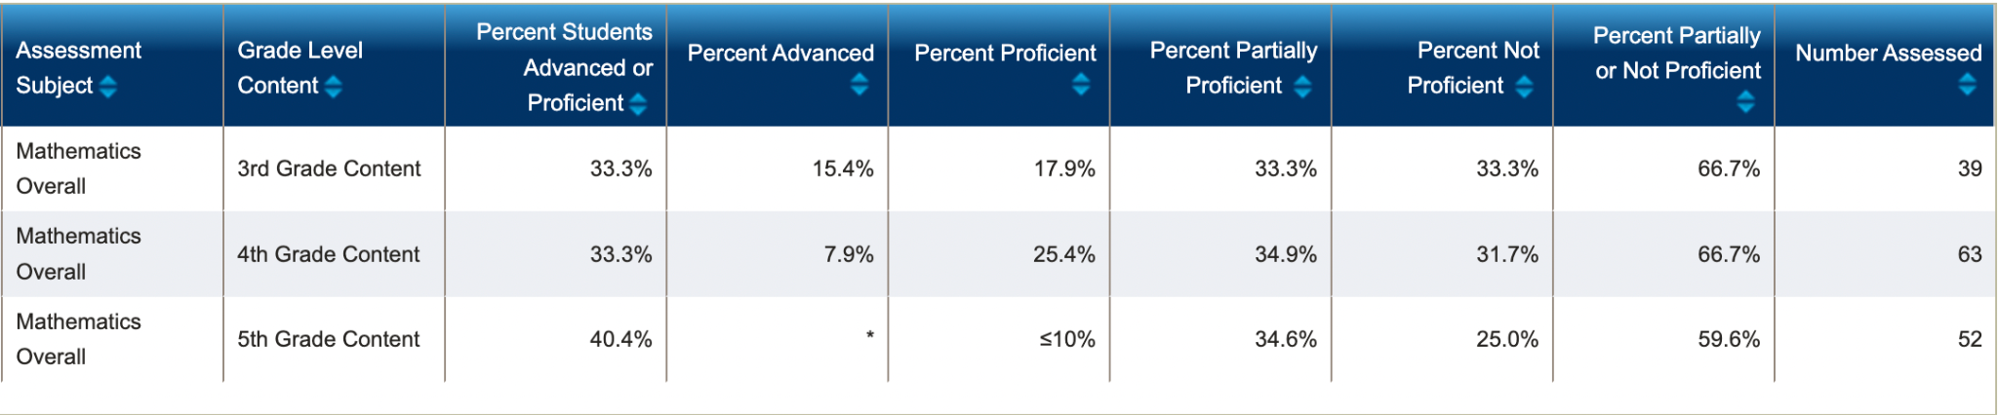
2021-22
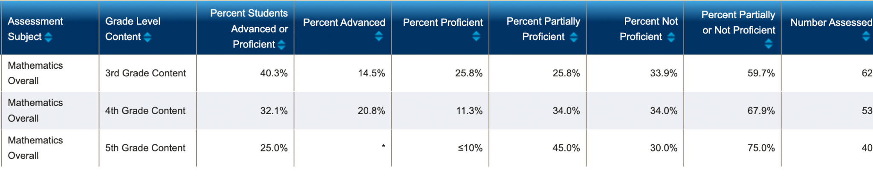

- IDENTIFY THE NUMBER AND PERCENT OF STUDENTS REPRESENTED BY PARENTS AT PARENT-TEACHER CONFERENCES
In Spring 2023, there were a total of 326 enrolled. Parent-Teacher Conferences, for a total of 97 % Participation. The trajectory for PTC participation for HLA has been between 96-98%.
Holland Language Academy’s dynamic staff has proven to rise above all adversity. The staff remains committed to student achievement. We are extremely grateful for the adaptability and flexibility that has been displayed by both students and staff as we have begun to look at adapting to the new curriculum.

Sincerely,

Iliana Vasquez
Holland Language Academy

