February 15, 2024

Dear Families and Community Members:

We are pleased to present you with the Annual Education Report (AER), which provides key information on the 2023-24 educational progress for Holland High School. The AER addresses the complex reporting information required by federal and state laws. The school’s report contains information about student assessment, accountability, and teacher quality. If you have any questions about the AER, please contact Andrea Mehall for assistance.

The AER is available for you to review electronically by visiting the following website https://www.mischooldata.org/, or you may review a copy in the main office at your child’s school.

For the 2023-24 school year, schools were identified based on previous years’ performance using definitions and labels as required in Every Student Succeeds Act (ESSA). A Targeted Support and Improvement (TSI) school is one that had at least one underperforming student subgroup in 2021-22. An Additional Targeted Support (ATS) school is one that had a student subgroup performing at the same level as the lowest 5% of all schools in the state in 2021-22. A Comprehensive Support and Improvement (CSI) school is one whose performance was in the lowest 5% of all schools in the state, had a 4-year graduation rate at or below 67%, or was in an ATS cohort but did not meet ATS exit criteria. Some schools are not identified with any of these labels. In these cases, no label is given.

Our school was identified as an Comprehensive Support and Improvement (CSI) in 2022-2023, as we were an ATS cohort but did not meet ATS exit criteria. We will remain a CSI school for three year cycle.

Holland High School administers the SAT, M-STEP, and WorkKeys assessments to all 11th grade students. The data trend that has emerged is the discrepancy between racial/ethnic groups who are assessed. Proficiency data for the 2023 administration of the SAT and M-STEP are included in the tables below.

Demographic Group  (SAT Evidence Based Reading and Writing:2023) | Meets/Exceeds Benchmark  (n=number of total students tested)
White | 62% (n=68)
Black / African-American | 15% (n=13)
Hispanic | 34% (n=102)

Demographic Group  (SAT Math:2022) | Meets/Exceeds Benchmark  (n=number of total students tested)
White | 37% (n=68)
Black / African-American | 8% (n=13)
Hispanic | 15% (n=102)

Demographic Group (M-STEP, 2023) | Percent Proficient  (n=number of total students tested)
White (M-STEP Science) | 58.5% (n=65)
Black / African-American (M-STEP Science) | 16.7% (n=12)
Hispanic (M-STEP Science) | 24.8% (n=101)
White (M-STEP Social Studies) | 52.3% (n=65)
Black / African-American (M-STEP Social Studies) | 8.3% (n=12)
Hispanic (M-STEP Social Studies) | 26% (n=100)

At Holland High School, our approach to addressing academic achievement gaps is multifaceted, focusing on both the academic and social-emotional development of our students. Central to this approach is the integration of Positive Behavior Supports and Interventions, which play a crucial role in bolstering students' confidence in their classes. This is achieved through recognizing their achievements in grades, behavior, and attendance, and is further enhanced by the introduction of the "5 Star Students" data system. This innovative platform not only incentivizes but also tracks engagement in pro-social behaviors and student engagement across the school community. To support students we have on-site mental health therapists, implement check-in/check-out procedures, and offer after-school tutoring. This is in addition to weekly Silent Sustained Reading and Academic Intervention during Advisory periods.
Professional development for staff is another key area of focus. Training on instructional pedagogy, a guaranteed viable curriculum, social competency, and equitable grading practices are regularly provided. We emphasize the importance of diversity, equity, and inclusion, celebrating heritage months and ensuring ongoing communication about growth opportunities in these areas. Many of our teachers are trained in Restorative Practices, incorporating Circles into their classroom instruction to foster a more inclusive and understanding environment. Additionally, key personnel are equipped with Crisis Prevention and Intervention training, specializing in verbal de-escalation techniques.

Our commitment extends to capacity-building across the board. This includes the hiring of additional staff such as a full-time Instructional Coach, an additional EL teacher and Instructional Assistant, and a campus safety monitor. Teachers engage in weekly Professional Learning Communities, focusing on standards, data analysis, and differentiation strategies, ensuring that instruction is tailored to meet the diverse needs of our students.

The effectiveness of these strategies is reflected in the marked improvement seen in the Michigan School Index Report, where Holland High School showed advancements in 5 out of 7 areas from the 2021-2022 to the 2022-2023 school year. This progress, spanning student growth, graduation rates, and English learner progress, underscores the dedication of our staff and students in driving educational success and closing achievement gaps.

State law requires that we also report additional information.
- PROCESS FOR ASSIGNING PUPILS TO THE SCHOOL
Board Policy 5120 - ASSIGNMENT TO SCHOOL, CLASS, AND GRADE for Holland Public Schools

The following guidelines shall be followed in assigning students to schools, classes, and grades. All inquiries regarding elementary and secondary school boundaries are to be directed to the Superintendent.

- School Assignment/Transfer
  - Fundamentally, student assignment to a school shall be determined by attendance areas. Such areas will be adjusted to balance class size, to maintain racial and socioeconomic balance, and to maintain teacher-student ratios.
  - When feasible, children in the same family will be assigned to the same school, but children may be assigned to different schools when they live in a divided area, an overloaded area, or when requested by a parent and they can provide their own transportation.
  - Whenever possible, commitments made, in writing, to parents in earlier years - either implicitly by tradition or verbally - will be given priority in the process of assigning students for the year ahead. Placement policies and individual placements will be reviewed annually and adjusted when necessary.
  - When parents request that their child attend a school other than the one in their attendance area, they will be asked to sign the Student Transfer Agreement.
  - When families relocate from one neighborhood to another within the District during the school year, the children affected may continue their education at their original school if parents provide transportation to/from school.
- Class and Grade Assignment/Transfer
  - Assignments to class and grade shall be made by the principal after consultation with relevant staff.
  - Placement will be based on several factors including the intellectual, physical, social, and emotional development of the student as revealed by the use of available data and observations of the staff.
  - Each principal shall establish the criteria, including the intellectual, social, and emotional characteristics, by which students are assigned to classes and/or teachers or are transferred after initial assignment.
- The following procedures shall be followed in a transfer of a student within a school:
  - A written request shall be made to the principal by the parent of the student, a professional staff member, or by a student. Transfer requests may also be initiated by the principal.
  - After consultation with the appropriate personnel, a determination regarding the validity of the request shall be made by the principal.

If the transfer request is initiated by the District or a minor student, parents shall be advised of the request and the reasons it will be beneficial to the student or is necessary to maintain program effectiveness. They shall be advised of their rights of appeal if they do not agree with the transfer.

- THE STATUS OF THE 3-5 YEAR SCHOOL IMPROVEMENT PLAN

The School Improvement Plan at Holland High School is strategically focused on enhancing both academic achievement and social competency. Central to this plan is the implementation of weekly Professional Learning Communities, which provide a platform for teachers to collaboratively review standards, analyze data, and discuss differentiation tactics. This is complemented by a robust Academic Intervention program during Advisory periods, offering targeted support to students in need. Recognizing the diverse needs of its student body, Holland High School has also intensified its support for English Learners by bringing on board an additional EL-certified teacher and an Instructional Assistant. Additionally, the launch of an EL Pre-Algebra course marks a significant step in catering to the specific academic needs of English language learners. These initiatives are aimed at providing personalized and effective learning experiences for all students.

Further strengthening our commitment to educational excellence, Holland High School has recently introduced an Instructional Coach. This role is instrumental in enhancing teaching methods across all classrooms. To better track student progress and set informed goals, Holland Public Schools has adopted the NWEA MAP Growth assessment. These measures, along with school-wide reading strategies, regular data analysis, instructional feedback, after-school tutoring, and a variety of activities celebrating positive student behavior, underscore our ongoing efforts. Holland High School remains dedicated to documenting and monitoring goals, strategies, and actions, all aimed at elevating the quality of instruction and boosting academic achievement in key areas like Reading and Mathematics, while also focusing on improving Social Competency among its students.

- A BRIEF DESCRIPTION OF EACH SPECIALIZED SCHOOL
1. Severe Multiple Impairments Classrooms
Two Special Education Programs designed to serve elementary age students with Severe Multiple Disabilities. These classrooms operate according to the regulations defined by the Individuals with Disabilities Education Act (IDEA) and the Michigan Administrative Rules for Special Education (R 340.1748).

2. Early Childhood Special Education Classrooms
Three Special Education Programs designed to serve Preschool age students (3 through 5 years) with Disabilities. These classrooms operate according to the regulations defined by the Individuals with Disabilities Education Act (IDEA) and the Michigan Administrative Rules for Special Education (R 340.1755).

3. Classrooms for students with Hearing Impairments
Three Special Education Programs designed to serve preschool through 12th grade students with Hearing Impairments. These classrooms operate according to the regulations defined by the Individuals with Disabilities Education Act (IDEA) and the Michigan Administrative Rules for Special Education (R 340.1742).

4. Autism Spectrum Disorder Classrooms
Three Special Education Programs designed to serve preschool through 12th grade students with ASD. These classrooms operate according to the regulations defined by the Individuals with Disabilities Education Act (IDEA) and the Michigan Administrative Rules for Special Education (R 340.1758).

- IDENTIFY HOW TO ACCESS A COPY OF THE CORE CURRICULUM, A DESCRIPTION OF ITS IMPLEMENTATION, AND AN EXPLANATION OF THE VARIANCES FROM THE STATE’S MODEL

The framework for developing curriculum is established through the Michigan Department of Education (MDE). Within that framework, local schools adopt the core curriculum as designed, or modify the curriculum to address local needs. Currently, our district has written curriculum maps Pre-K-12 for Math and ELA that are aligned to the Michigan Academic Standards. The Grade Level Content Expectations (GLCE’s) in the area of Social Studies will continue to be used.

Our curriculum is aligned with the State of Michigan content standards, which are contained in the Michigan Academic Standards Page, on the State of Michigan website: https://www.michigan.gov/mde/services/academic-standards

Pacing guides and curriculum guides are available on the district website or through the Office of School Improvement. Holland Public Schools has a defined guaranteed and viable curriculum for all students and core instruction time is held at a high standard.

- THE AGGREGATE STUDENT ACHIEVEMENT RESULTS FOR ANY LOCAL COMPETENCY TESTS OR NATIONALLY NORMED ACHIEVEMENT TESTS

The following data tables include assessment data from the following tests:
- School-Day Administration of SAT Plus Writing for Grade 11 (April, 2023)
- School-Day Administration of PSAT-10 for Grade 10 (April, 2023)
- School-Day Administration of PSAT 8/9 for Grade 9 (April, 2023)
- NWEA Map Growth- MATH for Grades 9-12 (Fall, 2023)
- NWEA Map Growth- READING Grades 9-12 (Fall, 2023)

School-Day Administration of SAT Plus Writing for Grade 11 (April, 2023)

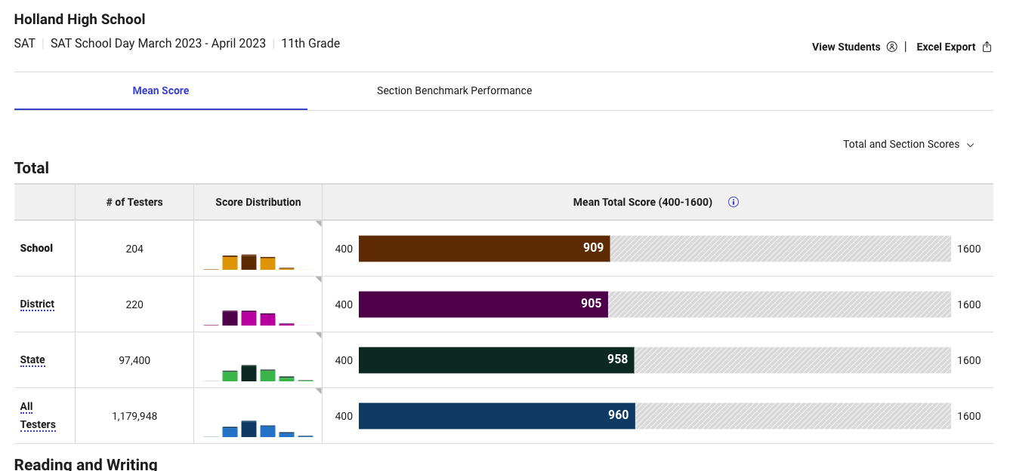

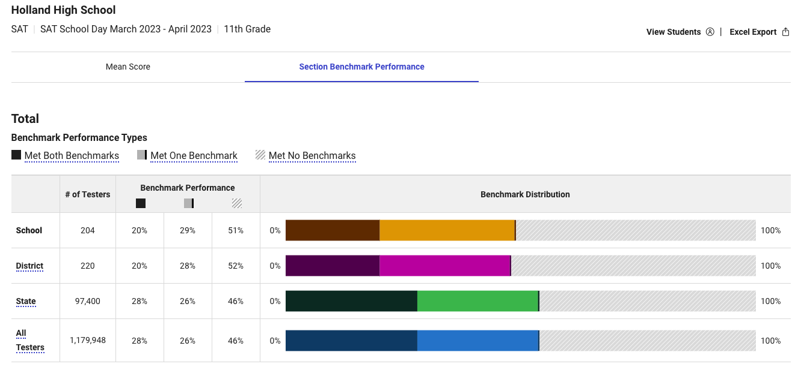

School-Day Administration of PSAT-10 for Grade 10 (April, 2023)

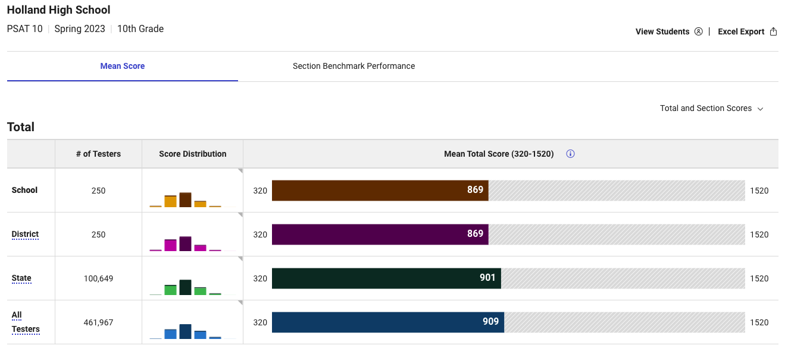

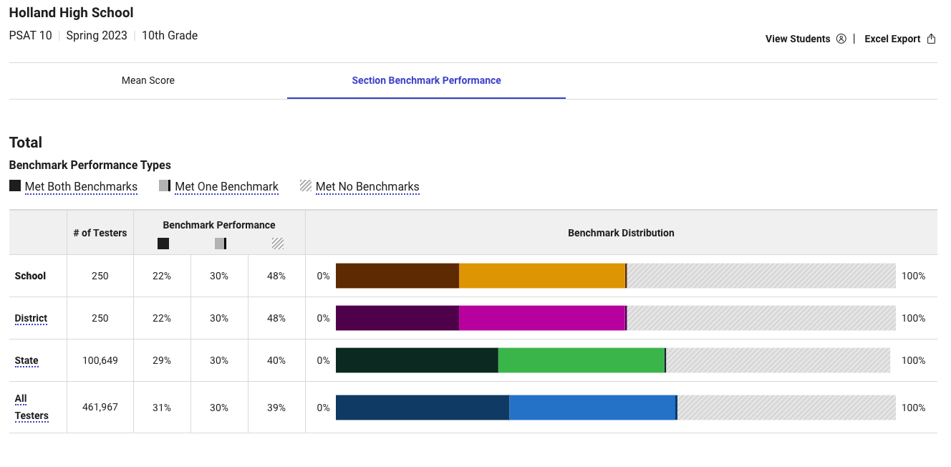

School-Day Administration of PSAT-8/9 for Grade 9 (April, 2023)

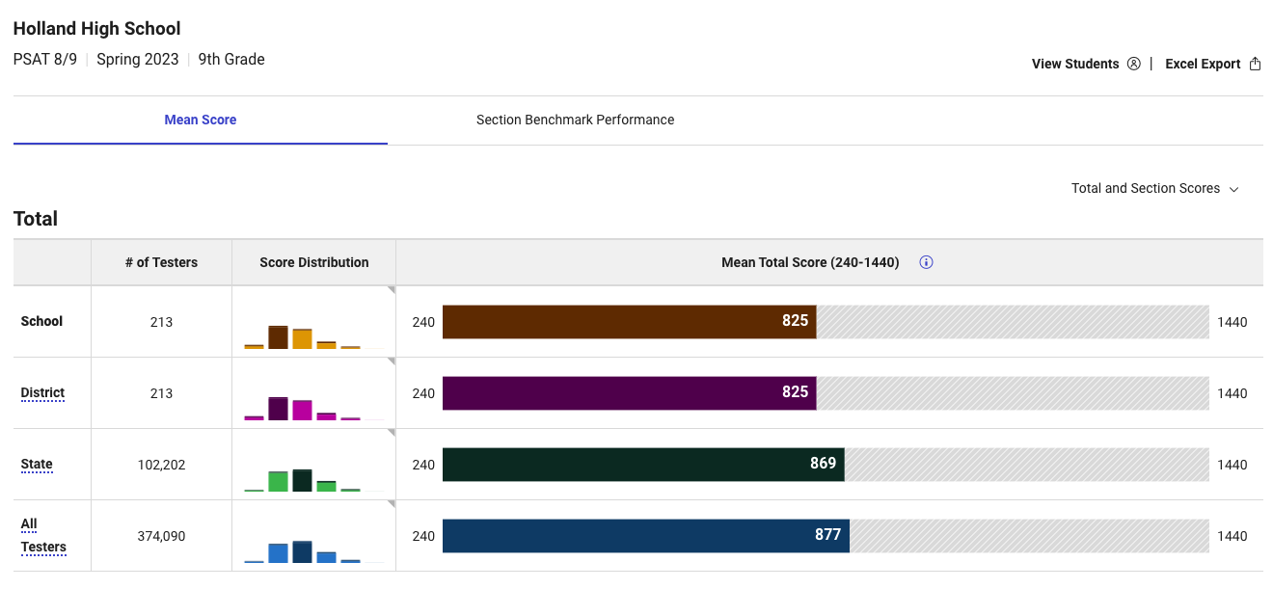

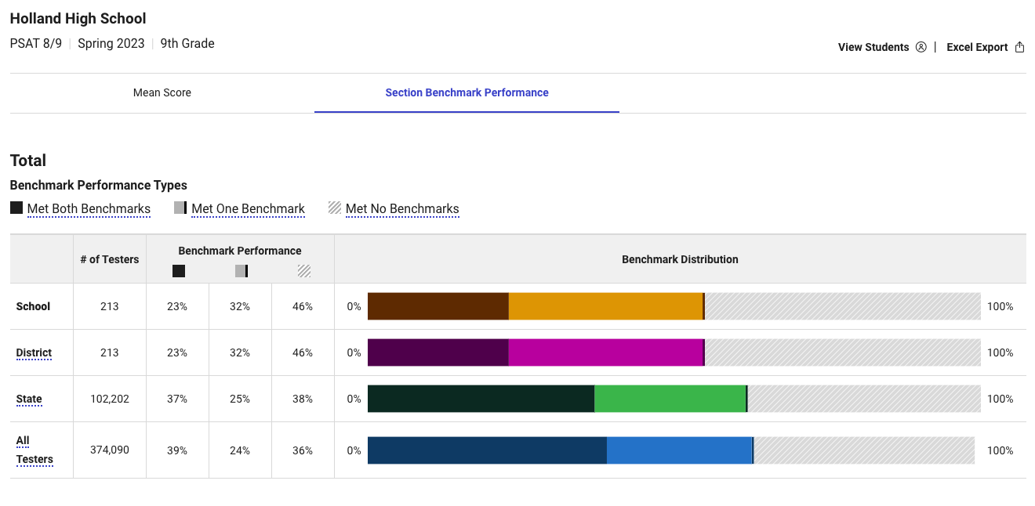

NWEA Map Growth- MATH

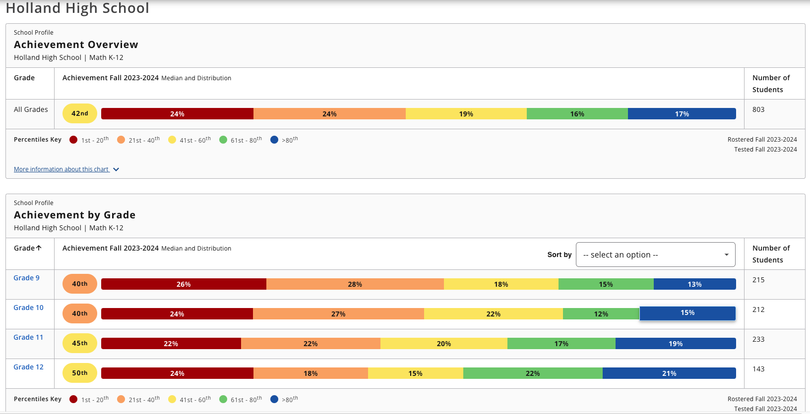

NWEA Map Growth- READING

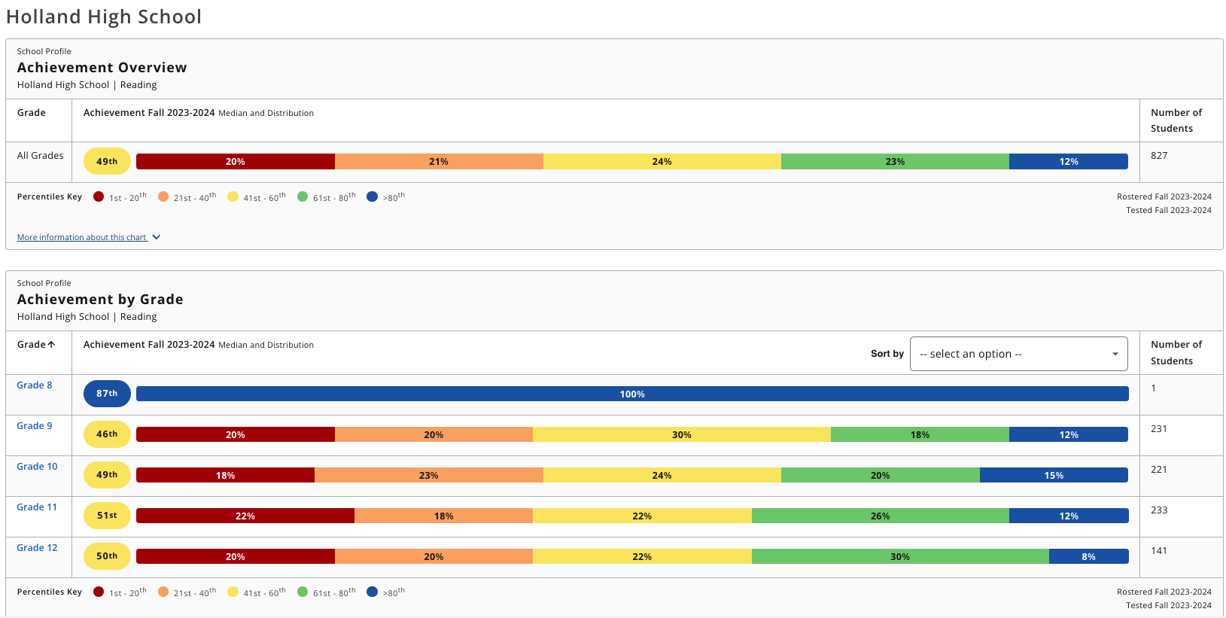

- IDENTIFY THE NUMBER AND PERCENT OF STUDENTS REPRESENTED BY PARENTS AT PARENT-TEACHER CONFERENCES

Conference Session | Number of Conferences Held | Percentage of Students Represented
Fall, 2019 (Traditional) | 1,541 | 27%
Fall, 2020 (Traditional) | 981 | 20%
Fall, 2021 (Student-Led) | 561 | 55.7%
Fall, 2022 (Student-Led) | 474 | 58%
Fall, 2023 (Traditional) | 225 | 23.6%

- FOR HIGH SCHOOLS, ONLY ALSO REPORT ON THE FOLLOWING:
  - THE NUMBER AND PERCENT OF POSTSECONDARY ENROLLMENTS (DUAL ENROLLMENT)

School Year | Number of Students in Dual Enrollment* | Percent of Enrolled Students
2019-2020 | 11 | 0.97%
2020-2021 | 15 | 1.40%
2021-2022 | 14 | 1.35%
2022-2023 | 22 | 2.27%
2023-2024 | 26 | 2.73%
*The data in the table above does not include the students enrolled in Davenport University courses through Holland Early College.

  - THE NUMBER OF COLLEGE EQUIVALENT COURSES OFFERED (AP/IB)
Holland High School offers twelve (12) Advanced Placement courses. Three of these courses are offered on an every-other-year basis in order to ensure sustainable enrollment (AP Biology, AP Chemistry, AP Physics). The remaining courses are offered annually. These include AP Calculus, AP English Language and Composition, AP English Literature and Composition, AP Psychology, AP Statistics, AP U.S. Government, AP World History, and AP Spanish Language and Culture.

  - THE NUMBER AND PERCENTAGE OF STUDENTS ENROLLED IN COLLEGE EQUIVALENT COURSES (AP/IB)

Subject | Number of Students Enrolled - 2023 | Number of Students Enrolled - 2022 | Number of Students Enrolled - 2021 | Number of Students Enrolled - 2020 | Number of Students Enrolled - 2019
AP Biology | 50 | 52 | Class not offered in 2020-2021. | 54 | Class not offered in 2018-2019.
AP Calculus | 32 | 25 | 26 | 36 | 42
AP Chemistry | Class not offered in 2023-2024 | Class not offered in 2021-2022 | 36 | Class not offered in 2019-2020. | 37
AP English Language and Composition | 63 | 52 | 48 | 73 | 67
AP English Literature and Composition | 27 | 17 | 31 | 40 | 51
AP Human Geography | Class not offered in 2021-2022 | Class not offered in 2021-2022 | 22 | Class not offered in 2019-2020. | 27
AP Physics | Class not offered in 2021-2022 | Class not offered in 2021-2022 | 19 | Class not offered in 2019-2020. | 15
AP Psychology | 44 | 24 | 51 | 56 | 58
AP Statistics | 50 | 45 | 48 | 54 | 70
AP U.S. Government | 73 | 79 | 40 | 84 | 97
AP U.S. History | 29 | Class not offered in 2021-2022 | Class not offered in 2020-2021. | Class not offered in 2019-2020. | 20
AP World History | 42 | 47 | 57 | 56 | 77
AP Spanish Language and Culture | 13 | 22 | Class not offered in 2020-2021. | Class not offered in 2019-2020. | Class not offered in 2018-2019.

Subject | Percentage of Total Students Enrolled - 2023  (n=951) | Percentage of Total Students Enrolled - 2022  (n=977) | Percentage of Total Students Enrolled - 2021 (n=1,032) | Percentage of Total Students Enrolled - 2020 (n=1,065) | Percentage of Total Students Enrolled - 2019 (n=1,130)
AP Biology | 5.25% | 5.3% | Class not offered in 2020-2021. | 5.0% | Class not offered in 2018-2019.
AP Calculus | 3.36% | 2.55% | 2.5% | 3.4% | 3.7%
AP Chemistry | Class not offered in 23-24 | Class not offered in 2021-2022 | 3.4% | Class not offered in 2019-2020. | 3.2%
AP English Language and Composition | 6.62% | 5.3% | 4.6% | 6.8% | 5.9%
AP English Literature and Composition | 2.84% | 1.74% | 3.0% | 3.7% | 4.5%
AP Human Geography | Class not offered in 23-24 | Class not offered in 2021-2022 | 2.1% | Class not offered in 2019-2020. | 2.3%
AP Physics | Class not offered in 23-24 | Class not offered in 2021-2022 | 1.8% | Class not offered in 2019-2020. | 1.3%
AP Psychology | 4.62% | 2.45% | 4.9% | 5.2% | 5.1%
AP Statistics | 5.25% | 4.6% | 4.6% | 5.0% | 6.2%
AP U.S. Government | 7.67% | 8.08% | 3.8% | 7.9% | 8.6%
AP U.S. History | 3.04% | Class not offered in 2021-2022 | Class not offered in 2020-2021. | Class not offered in 2019-2020. | 1.7%
AP World History | 4.41% | 4.8% | 5.5% | 5.2% | 6.8%
AP Spanish | 1.36% | 2.25% | Class not offered in 2020-2021. | Class not offered in 2019-2020. | Class not offered in 2018-2019.

  - THE NUMBER AND PERCENTAGE OF STUDENTS RECEIVING A SCORE LEADING TO COLLEGE CREDIT

Subject | 3 or higher - 2023 | 3 or higher - 2022 | 3 or higher - 2021 | 3 or higher - 2020 | 3 or higher - 2019
AP Biology | Class not offered in 2022-2023 | 71% (n=22) | Class not offered in 2020-2021. | 63.9% (n=23) | Class not offered in 2018-2019.
AP Calculus | 7% (n=1) | 17.6% (n=3) | 23.5% (n=4) | 61.5% (n=16) | 59.3% (n=16)
AP Chemistry | 89% (n=8) | Class not offered in 2021-2022. | 17.9% (n=5) | Class not offered in 2019-2020. | 32.0% (n=8)
AP English Language and Composition | 40% (n=20) | 57.5% (n=19) | 68.4% (n=26) | 55.6% (n=25) | 38.8% (n=19)
AP English Literature and Composition | 100% (n=10) | 70% (n=7) | 23.1% (n=3) | 50.0% (n=12) | 45.2% (19)
AP Human Geography | Class not offered in 2021-2022. | Class not offered in 2021-2022. | 7.7% (n=1) | Class not offered in 2019-2020. | 6.3% (n=1)
AP Physics | 44% (n=7) | Class not offered in 2021-2022. | 55.6% (n=5) | Class not offered in 2019-2020. | 40.0% (n=4)
AP Psychology | 60% (n=9) | 68.7% (n-11) | 81.8% (n=10) | 50.0% (n=14) | 68.6% (n=24)
AP Statistics | 33% (n=2) | 27.2% (n=6) | 40.0% (n=2) | 30.0% (n=3) | 50.0% (n=14)
AP U.S. Government | 11% (n=4) | 10.2% (n=4) | 19.4% (n=6) | 30.5% (n=18) | 22.6% (n=14)
AP U.S. History | 14% (n=1) | Class not offered in 2021-2022. | Class not offered in 2020-2021. | Class not offered in 2019-2020. | 53.8% (n=7)
AP World History | 46% (n=22) | 51.4% (n=18) | 22.9% (n=8) | 44.7% (n=17) | 47.6% (n=20)

The future is bright for Holland High School, and the measures that have been put in place will undoubtedly put HHS on the path to closing our achievement gaps and preparing our students for college and career readiness. If you have any questions about the information contained in this letter, please do not hesitate to contact me at amehall@hollandpublicschools.org or (616) 494-2200.

Sincerely,
Andrea Mehall
Holland High School Principal

